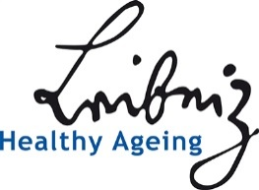
Application Travel Award

3rd International Symposium Healthy Ageing
20 – 22 February 2019
at the Leibniz-Forschungsinstitut für Molekulare Pharmakologie (FMP) in Berlin-Buch / Germany

Name

Contact data

Focus of the own research (max 500 characters including spaces)

Focus Group applied for

Motivation of the application (max. 700 characters incl. spaces)

Publications (max. 3)

Time schedule
Call | 30 October 2018
Deadline for application | 30 November 2018
Decision by the heads of the focus groups | 14 December 2018
Registration deadline for award winners | 4 January 2019

Please send the application to
LRA Healthy Ageing, Astrid van der Wall, astrid.vanderwall@leibniz-fli.de

